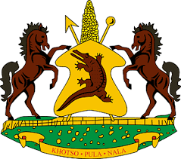
MINISTRY OF TOURISM, ENVIRONMENT AND CULTURE

NOTICE
Bokong Concession - Change of Submission Date
Following the Prime Minister’s directive to close all non-essential services until 21st April 2020 in line with Government’s efforts to curb the spread of Covid 19, the Ministry of Tourism, Environment and Culture adheres to the instruction and, therefore, notifies the General Public that we shall not be in operation as directed. In view of this, we equally make you aware of the impending submissions of bids for the re-above mentioned tender whose deadline is 2nd April 2020. We, therefore, advise that the deadline has been moved to 30th April 2020 to allow prospective bidders enough time to submit.

